HTTP + JSON + HTML + Email from HTML
https://openlibrary.org/search.json?q=isbn_9780262033848
Steps to follow:
- Create an Instant flow as trigger
- Add input text column to get the ISBN number as user input
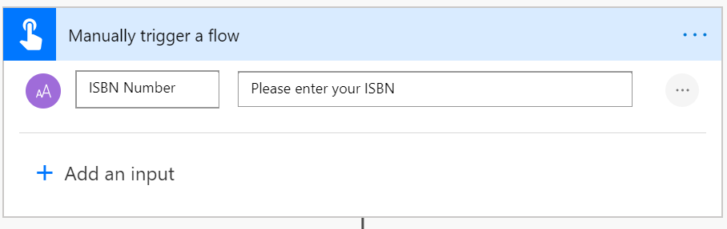
- Add an action HTTP
- Enter Method = Get and URI = url of the rest api and pass the input parameter
- If required add the Headers and body content based on your REST API
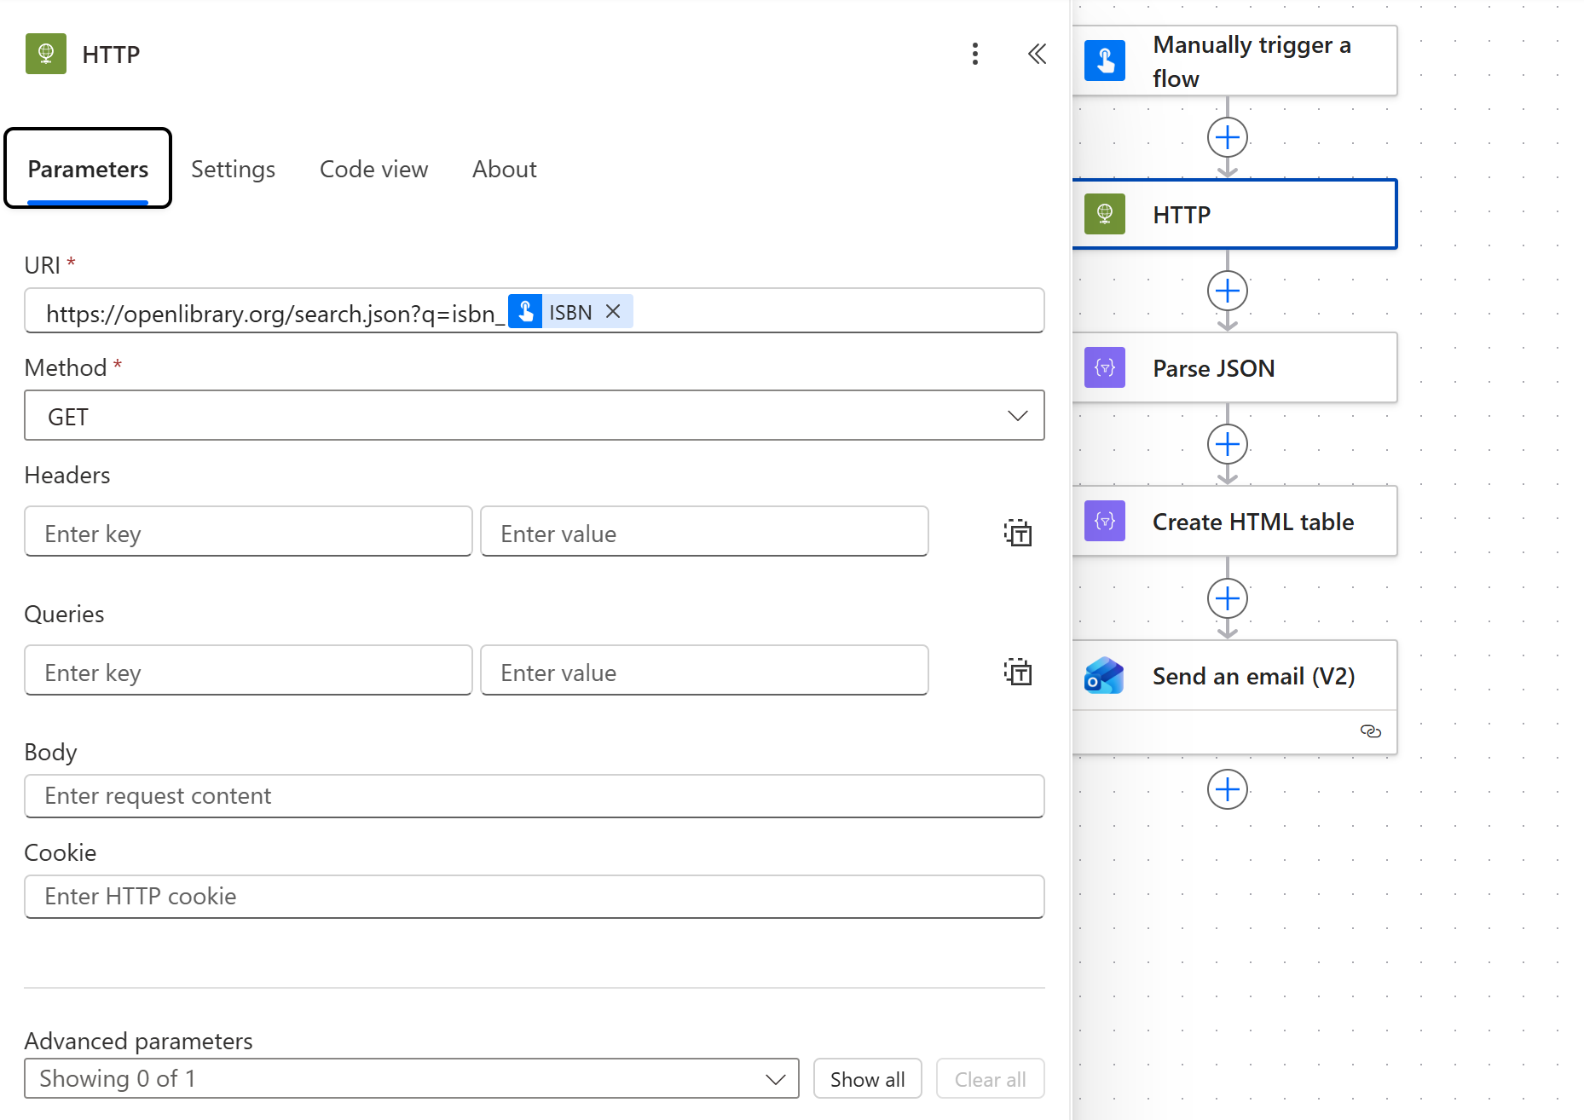
- Add another action Parse JSON to handle the response object
- Open the API url from browser and copy the output
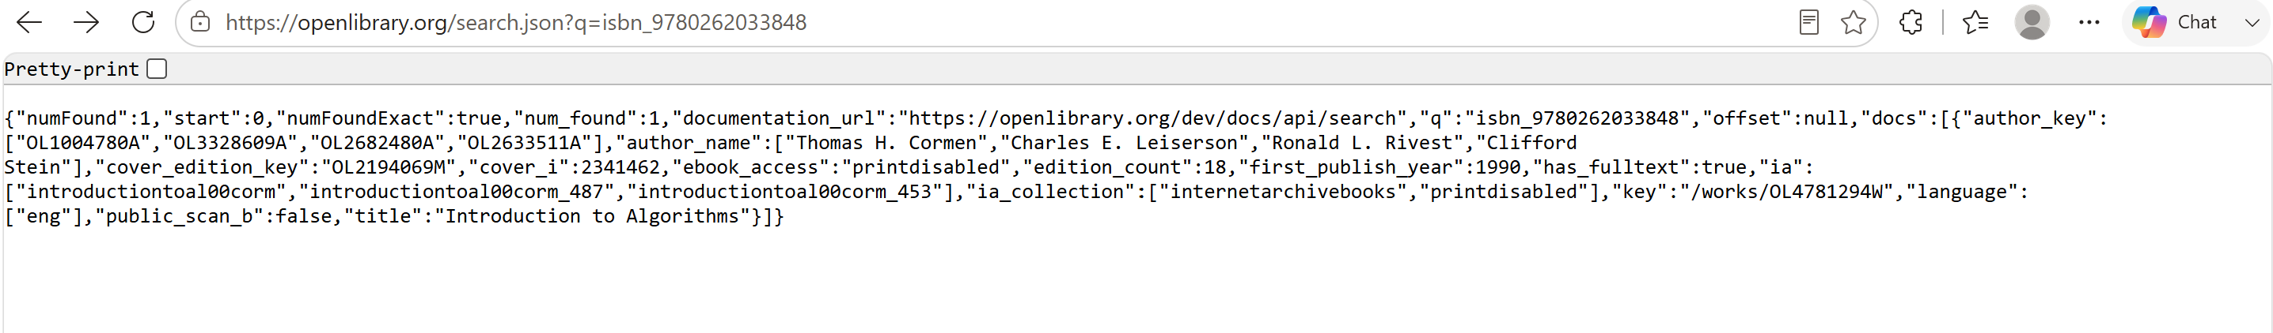
- Click Generate from sample button and add the any output from your rest api to create schema.
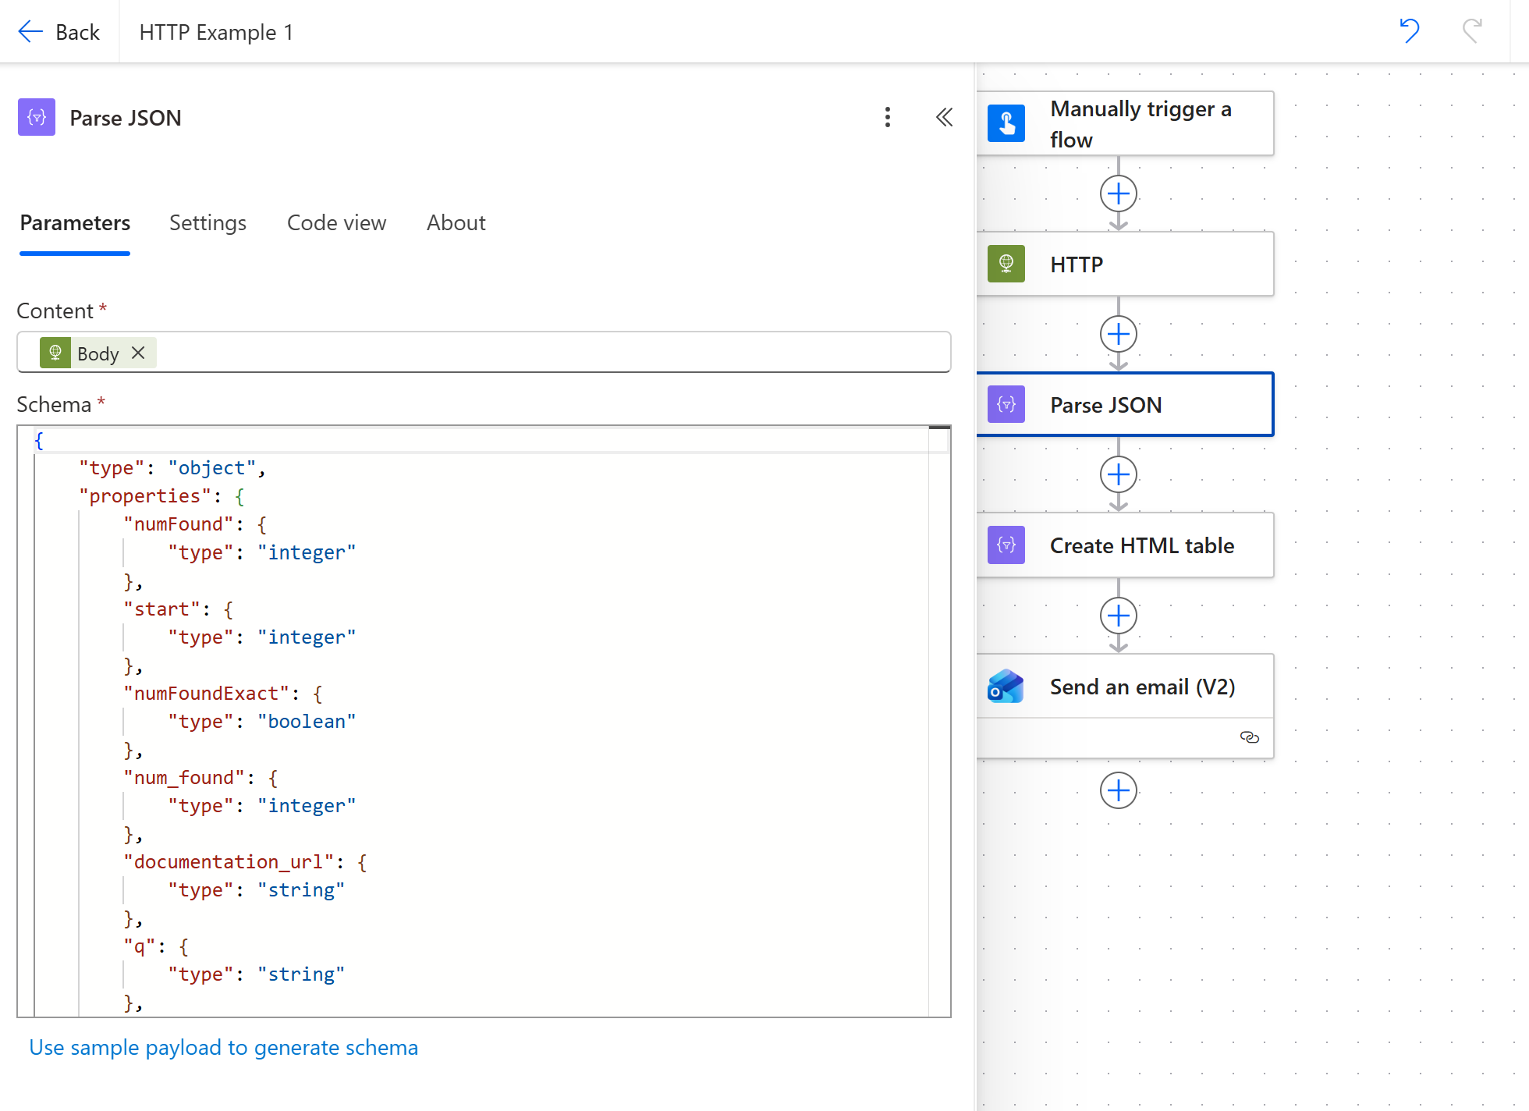
- Add another action to convert the items as HTML
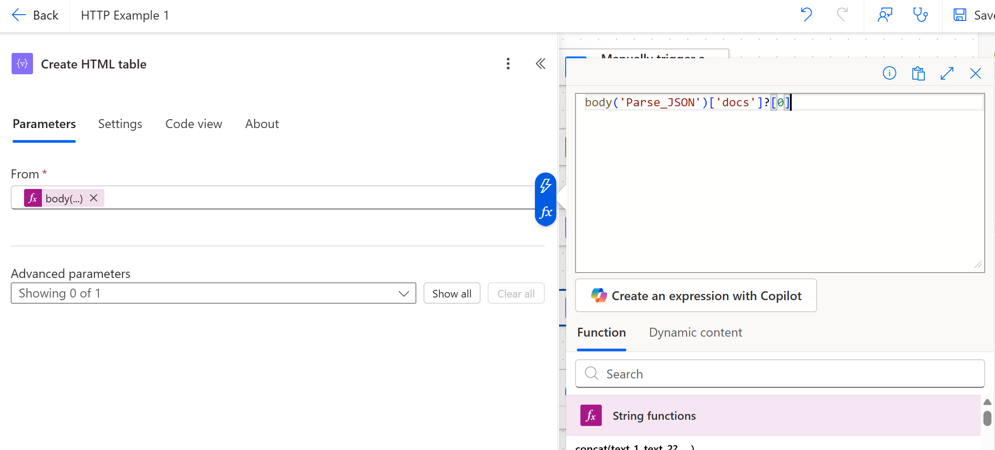
- Add another action to send email
- Add html output
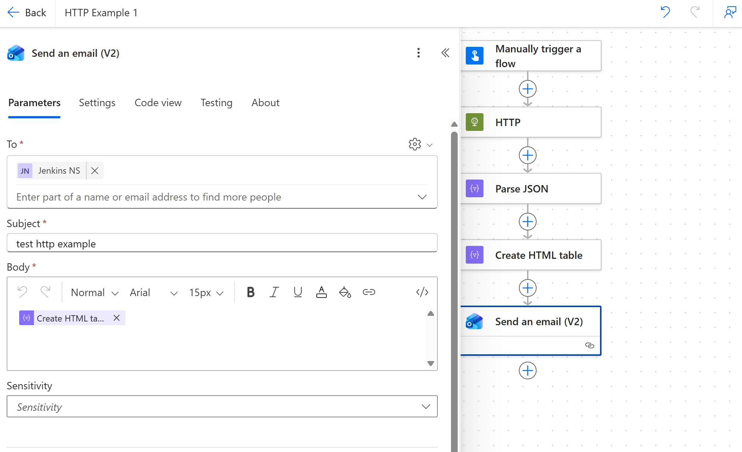
- Save and test the flow

